Practicum Journal
Operation System
Module 4: Reading the Xinu Source Code
Objectives:
- Students are able to read and understand the structure of Xinu source code.
- Students are able to perform simple modifications to Xinu.

Notes:
- Practitioners are required to screenshot every step taken until the final output display.
- For source code questions, submit only the screenshots.
- Practitioners are required to take screenshots with the root name. Example: root@username.
- Provide identity name - ID number in the form of comments in the Source Code.
- Please work independently, if you don't understand, please ask your respective Practicum Assistant. It is prohibited to copy answers and source code from friends!

Journal

- [10 Points] What is the name of the image generated after compiling Xinu? What is the size of the file? In which folder is the image file located?
Hint: Review the previous modules.

- Reading Xinu source code
  - Check Sourcetrail on your PC. If not available, download SourceTrail (SOURCETRAIL DOWNLOAD). SourceTrail is software for exploring source code. Good programmers read code more than they write.
  - Download the xinu source code file available in the practical journal attempt on the LMS.
  - Run SourceTrail.
  - Project New Project.
  - Enter the project name "xinu" and choose the project location anywhere.
  - Add Source Groups, select C, and choose Empty Source Group.
  - File & Directories to Index: add all Xinu folders.
  - Include Paths: .../xinu/include.
  - Create.
  - Explore Xinu source code.

- [10 Points] Find the data structure of processes in Xinu OS. In which file is the process data structure located? What information is stored in this data structure?
Hint: File with .h extension.

On Linux, you can use the "grep" command.
Example:
$ grep -r "word_to_search" /path/to/directory/where/file/is/located

- [80 Points] Changing the welcome banner on Xinu
  - Find the file that stores the Xinu banner!
Hint: files with the .h extension in the xinu/include directory
  - Find the file that displays the Xinu banner!
Hint: files with the .c extension in the xinu/shell directory
  - Change the Xinu welcome banner to look like this:
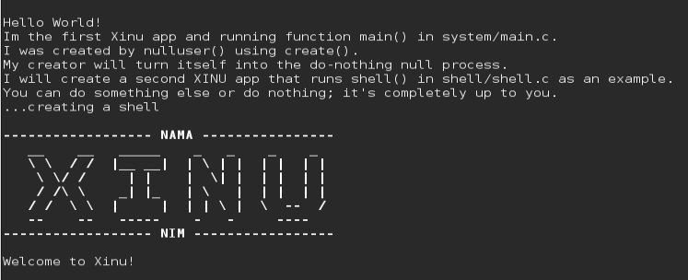
Add your name (NAMA) and student ID number (NIM), then change the Xinu banner to suit your taste.
  - After making changes, execute the following commands in the Linux terminal:
- $ cd xinu/compile
- $ make clean
- $ make
- $ sudo minicom
- Run the backend VM.

